**BookBazaar: Scalable E-commerce Bookstore Platform with AWS**

**Project Description**

With the increasing demand for convenient and digital access to books, traditional bookstores often struggle with limited inventory, geographical constraints, and inefficient order management. Readers and students face challenges such as unavailability of required books, lack of centralized platforms, and delays in order processing. To address these issues, the development team introduced BookBazaar—a smart, cloud-based online bookstore management system.

Built using Flask for backend development, hosted on AWS EC2, and integrated with DynamoDB for scalable data management, the platform allows users to register, log in, browse books, and place orders online with ease. Users can explore books by category, author, or title and complete purchases in just a few clicks. Upon successful order placement, AWS SNS sends instant email notifications confirming order details, thereby enhancing user trust and engagement.

This cloud-native solution streamlines the entire book purchasing and order management process, ensuring a fast, scalable, and user-friendly e-commerce experience for customers, sellers, and administrators.

**Scenario 1: Efficient Online Book Ordering System for Users**

In the BookBazaar system, AWS EC2 provides a reliable infrastructure capable of handling multiple users accessing the platform simultaneously. For example, a user can log in, navigate to the book catalogue, and seamlessly browse available books across various categories such as academics, fiction, and competitive exam materials.

Users can view book details including author, price, availability, and description. They can add books to the cart and proceed to checkout in real time. Flask manages the backend logic, ensuring smooth data flow, fast response times, and secure transactions—even during peak usage periods such as exam seasons or festive sales.

**Scenario 2: Seamless Order Confirmation Notifications**

When a user completes a book order, the BookBazaar system leverages AWS SNS to send instant email notifications confirming the order. Once the checkout process is completed, Flask processes the order details and publishes a message to the SNS topic.

The SNS service then sends a customized email to the user containing order information such as book titles, order ID, total price, and delivery status. This real-time notification system enhances customer confidence and transparency, while DynamoDB securely stores order records for both users and administrators to manage and track efficiently.

**Scenario 3: Inventory and Order Management for Sellers and Admins**

The BookBazaar platform provides sellers with an easy-to-use interface for managing book listings and inventory. Sellers can add new books, update prices, and manage stock availability. Flask dynamically updates this information in DynamoDB, ensuring real-time synchronization across the platform.

Administrators oversee platform operations such as monitoring orders, managing users, validating seller activity, and ensuring system performance. The EC2-hosted application remains stable and responsive, even during traffic spikes, allowing administrators to efficiently maintain platform integrity.

**AWS ARCHITECTURE**

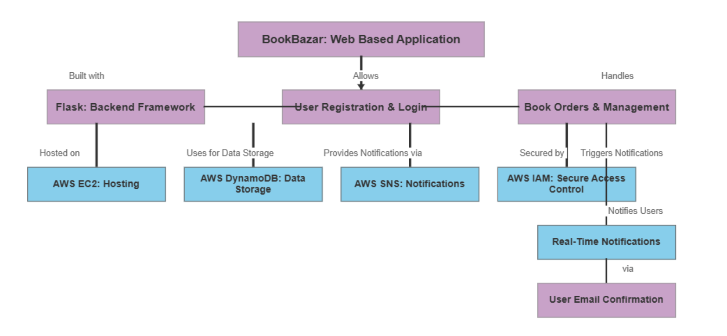

**Entity Relationship (ER)Diagram:**

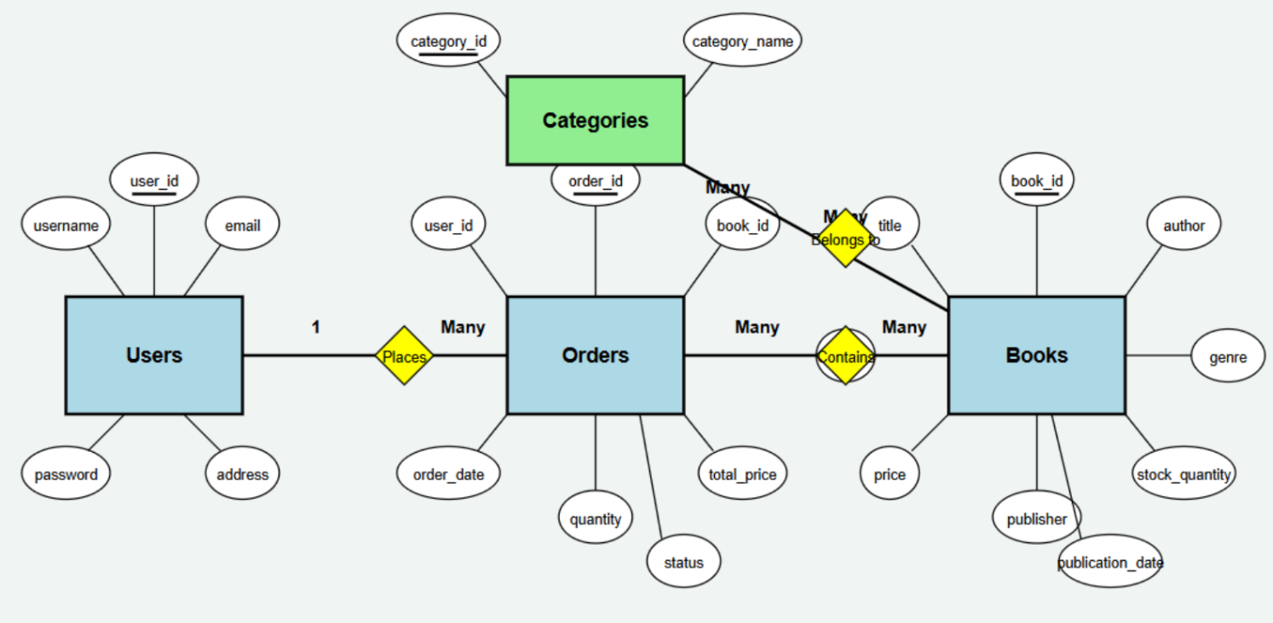

**Pre-requisites**

1. **AWS Account Setup – AWS Account Setup**
2. **Understanding IAM – IAM Overview**
3. **Amazon EC2 Basics – EC2 Tutorial**
4. **DynamoDB Basics – DynamoDB Introduction**
5. **SNS Overview – SNS Documentation**
6. **Git Version Control – Git Documentation**

**Project Workflow**

**1. AWS Account Setup and Login**

* **Activity 1.1:** Set up an AWS account if not already done
* **Activity 1.2:** Log in to the AWS Management Console

**2. DynamoDB Database Creation and Setup**

* **Activity 2.1:** Create DynamoDB tables
* **Activity 2.2:** Configure attributes for user, book, and order data

**3. SNS Notification Setup**

* **Activity 3.1:** Create SNS topics for order notifications
* **Activity 3.2:** Subscribe users to SNS email notifications

**4. Backend Development and Application Setup**

* **Activity 4.1:** Develop backend using Flask
* **Activity 4.2:** Integrate AWS services using boto3

**5. IAM Role Setup**

* **Activity 5.1:** Create IAM role
* **Activity 5.2:** Attach required policies

**6. EC2 Instance Setup**

* **Activity 6.1:** Launch EC2 instance
* **Activity 6.2:** Configure security groups for HTTP and SSH

**7. Deployment on EC2**

* **Activity 7.1:** Upload Flask files
* **Activity 7.2:** Run the Flask application

**8. Testing and Deployment**

* **Activity 8.1:** Conduct functional testing

**Milestone 1: AWS Account Setup and Login**

* **Activity 1.1: Set up an AWS account if not already done.** 
  + Sign up for an AWS account and configure billing settings.

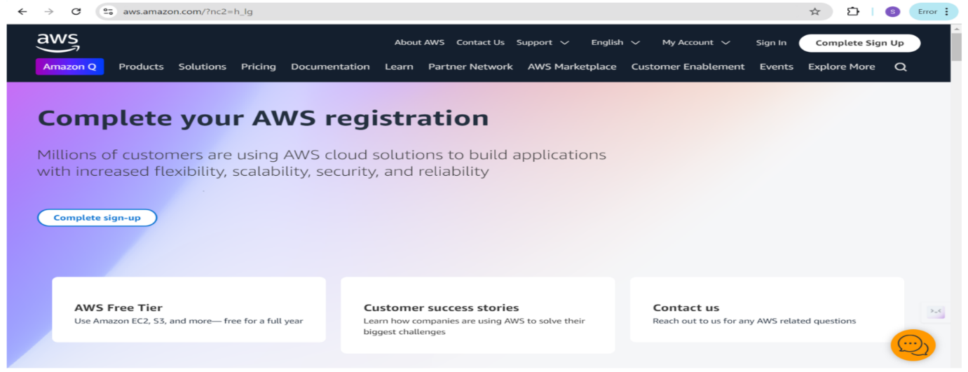

* Activity 1.2: Log in to the AWS Management Console
  + After setting up your account, log in to the AWS Management Console.

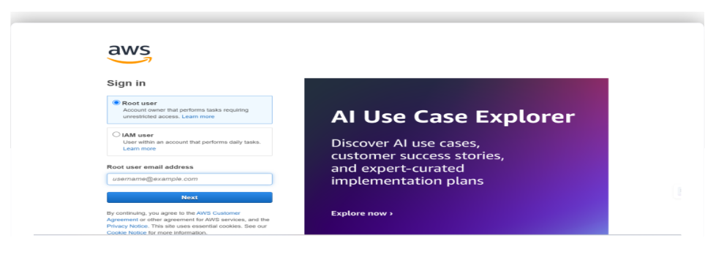

**Milestone 2: DynamoDB Creation and Setup**

* **Activity 2.1: Navigate to the DynamoDB** 
  + 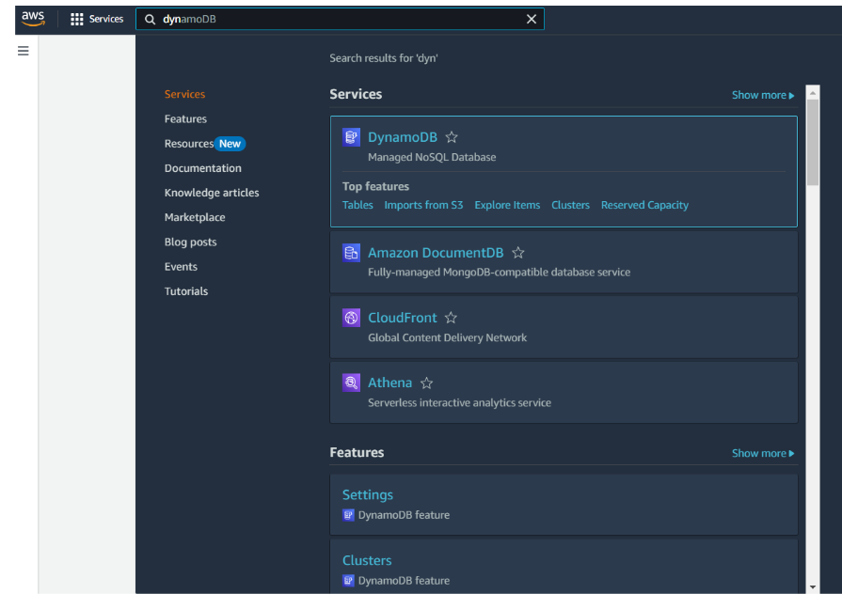In the AWS Console, navigate to DynamoDB and click on create tables.

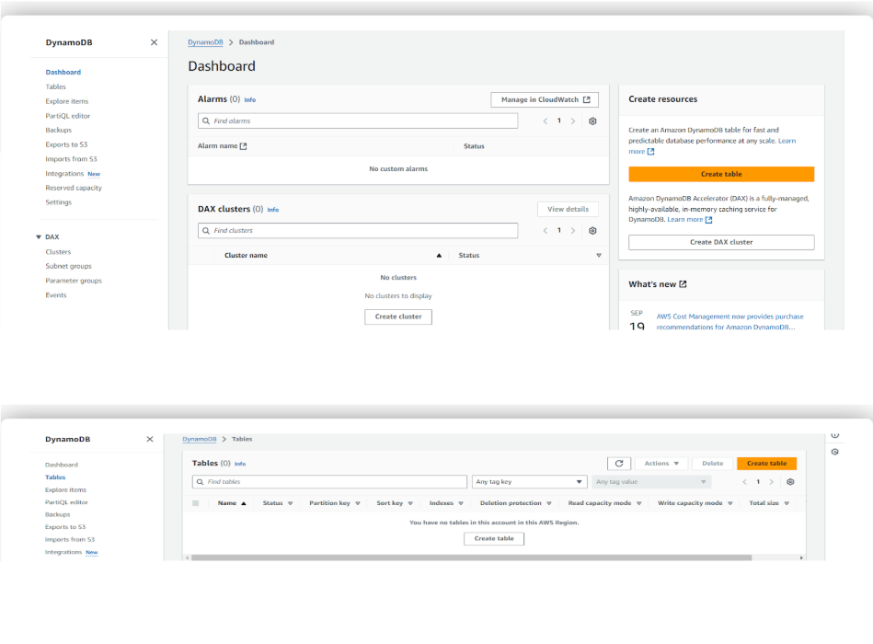

* **Activity 2.2: Create a DynamoDB table for storing BookBazaar Users details and BookBazaar Bookings.**
  + Create Users table with partition key “Username” with type String and click on create tables.

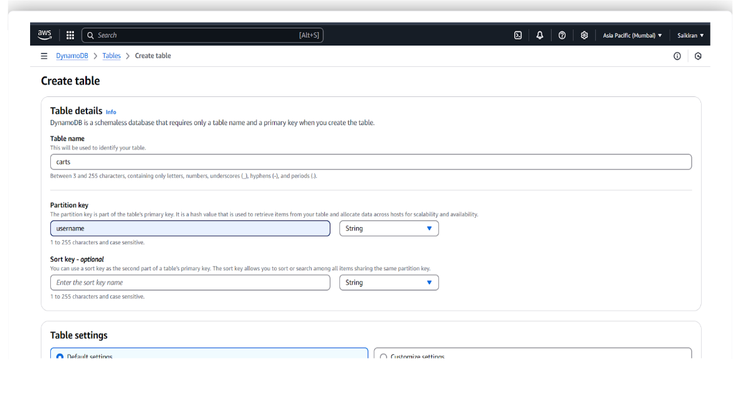

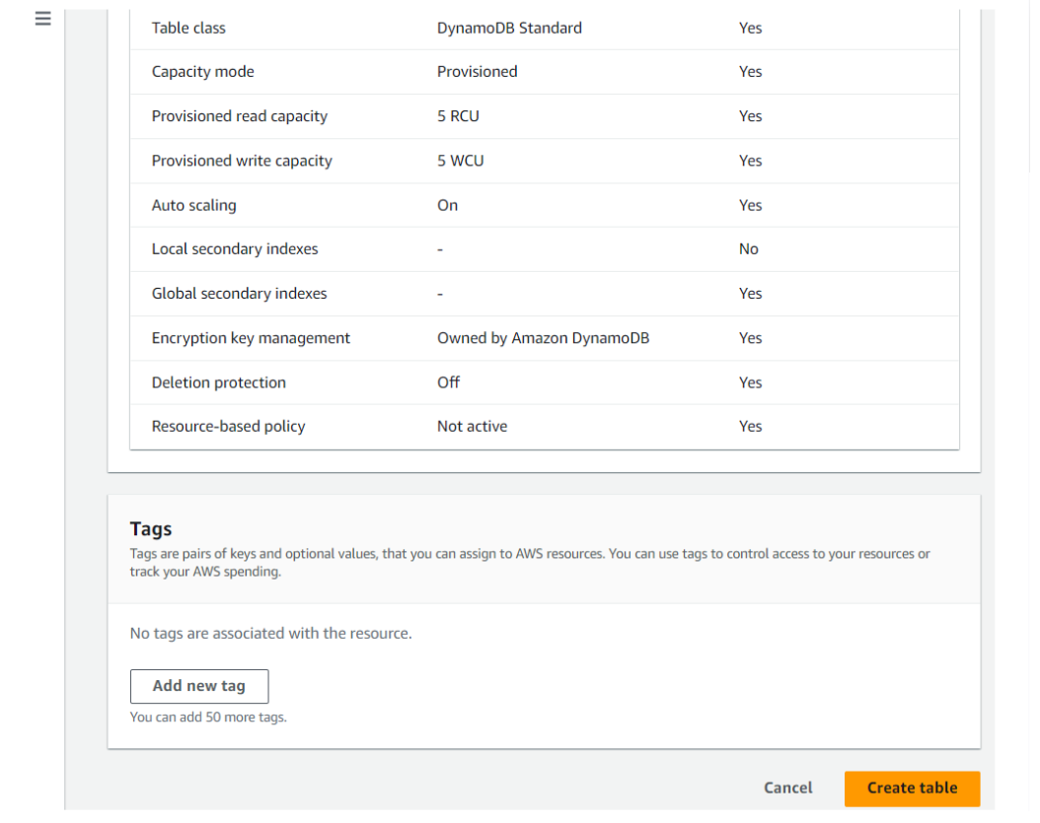

* Follow the same steps to create remaining tables with id as the primary key for BookBazaar data.

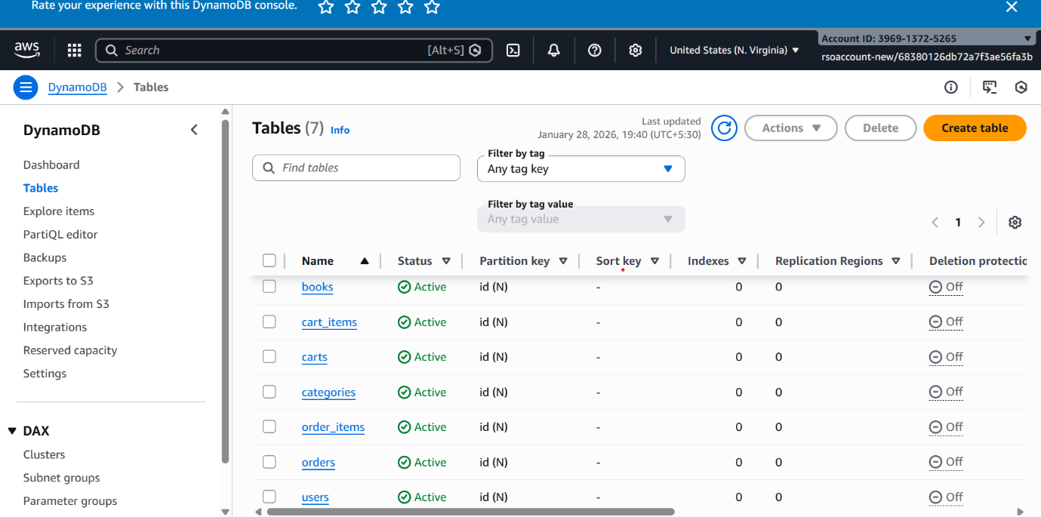

**Milestone 3: SNS Notification Setup**

* **Activity 3.1: Create SNS topics for sending email notifications to users regarding booking confirmation of their ticket.** 
  + In the AWS Console, search for SNS and navigate to the SNS Dashboard.

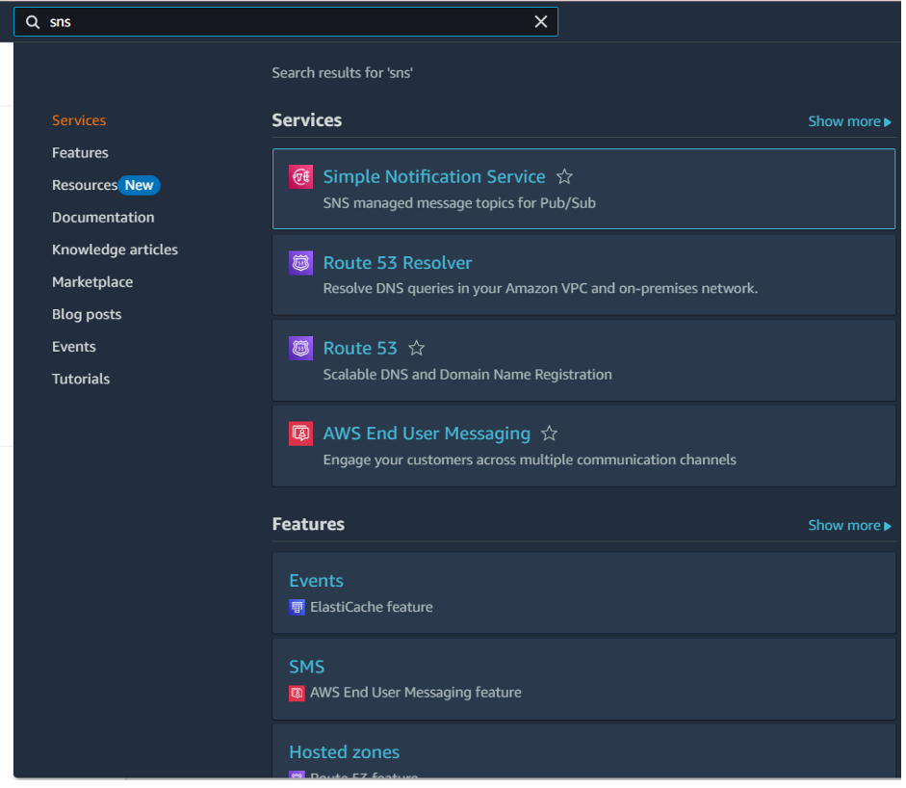

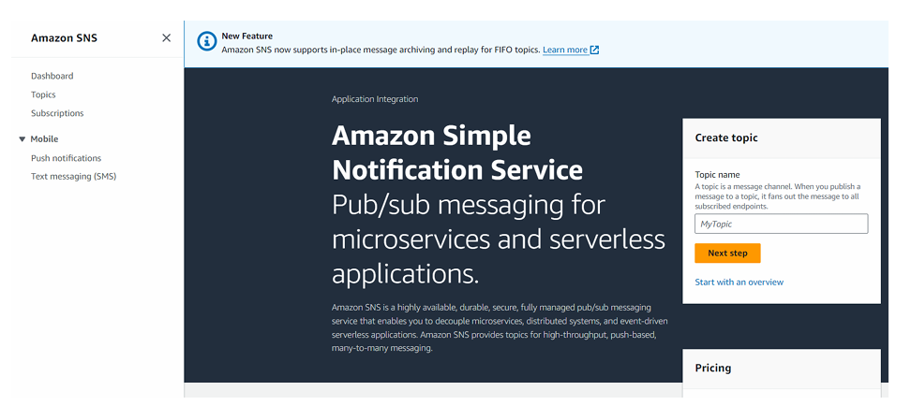

* + Click on Create Topic and choose a name for the topic.

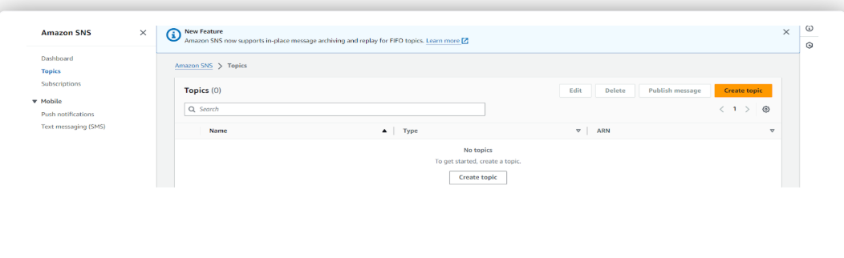

* + Choose Standard type for general notification use cases and Click on Create Topic.

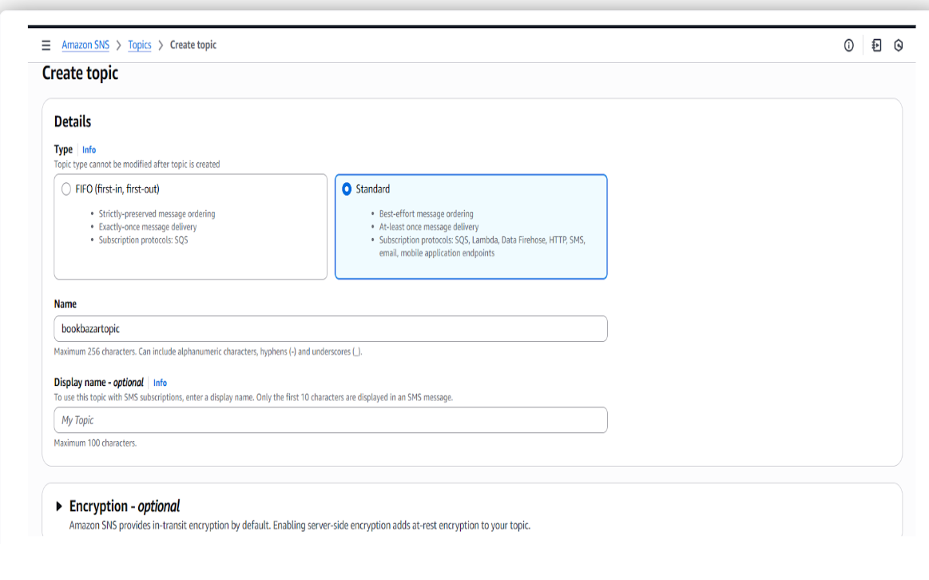

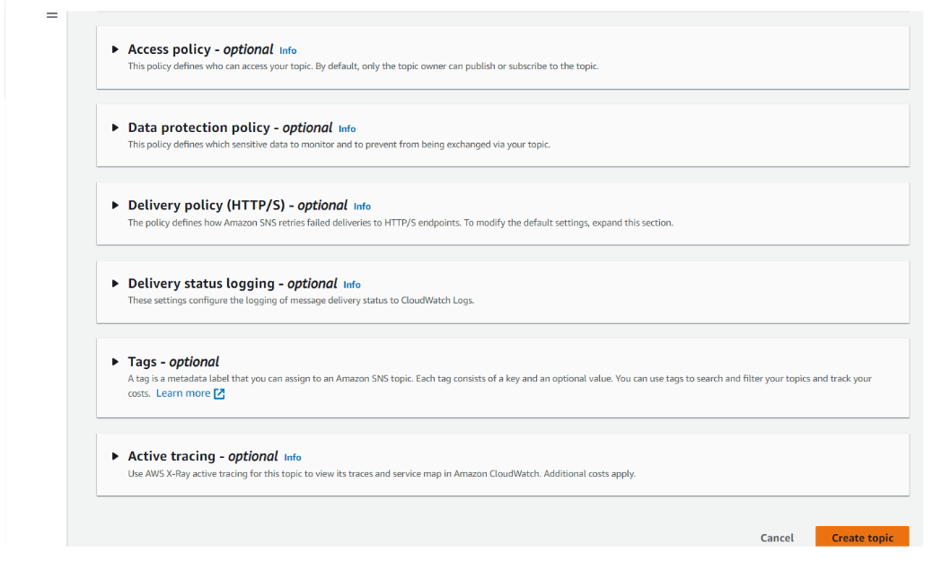

* + Configure the SNS topic and note down the **Topic ARN**.

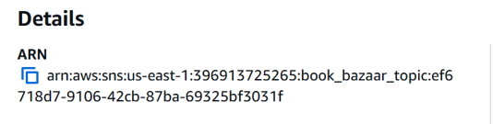

* **Activity 3.2: Subscribe users and staff to relevant SNS topics to receive real-time notifications when a movie booking is made.** 
  + 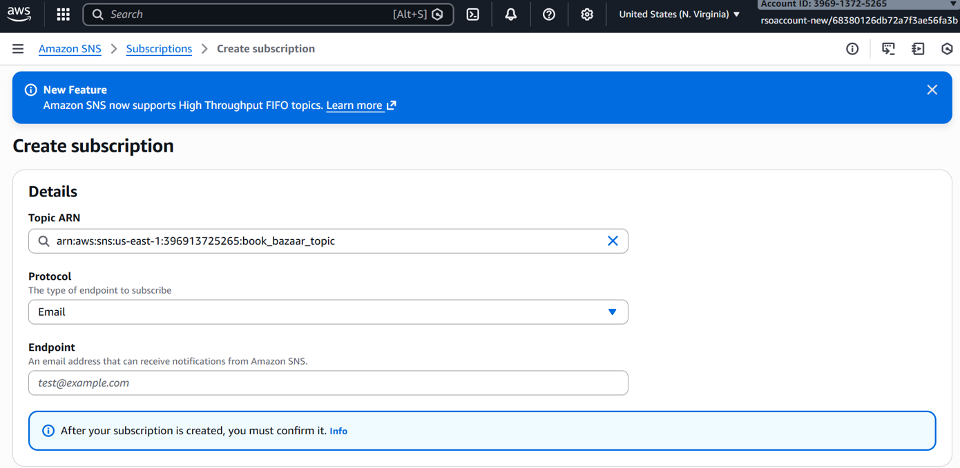Subscribe users (or admin staff) to this topic via email. When a movie ticket is booked, notifications will be sent to the user’s emails**.**

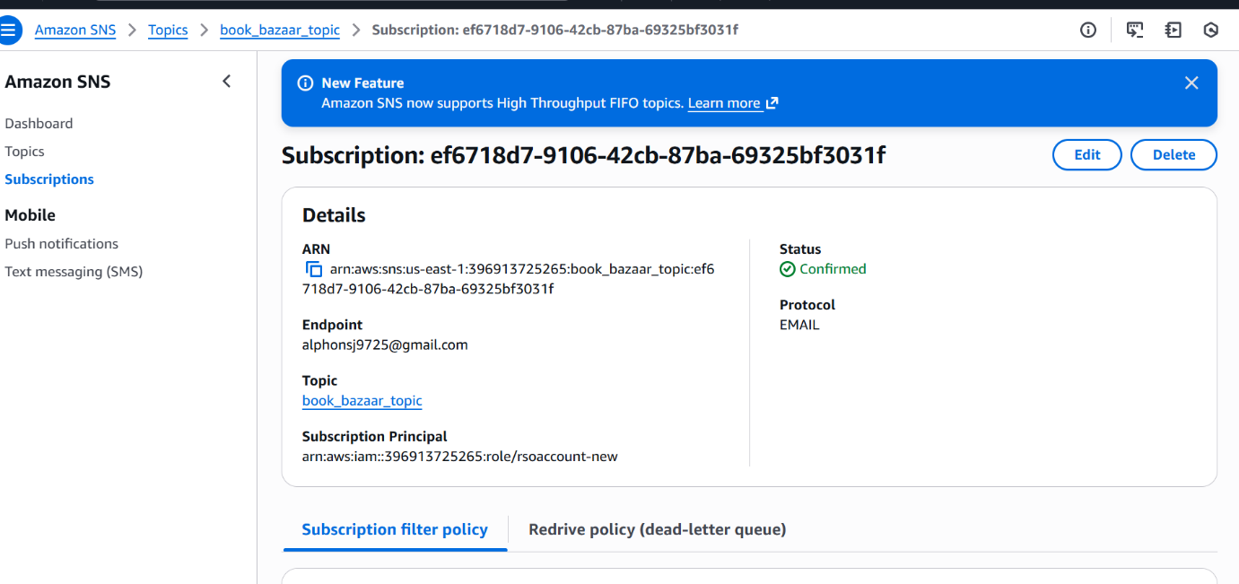

* + 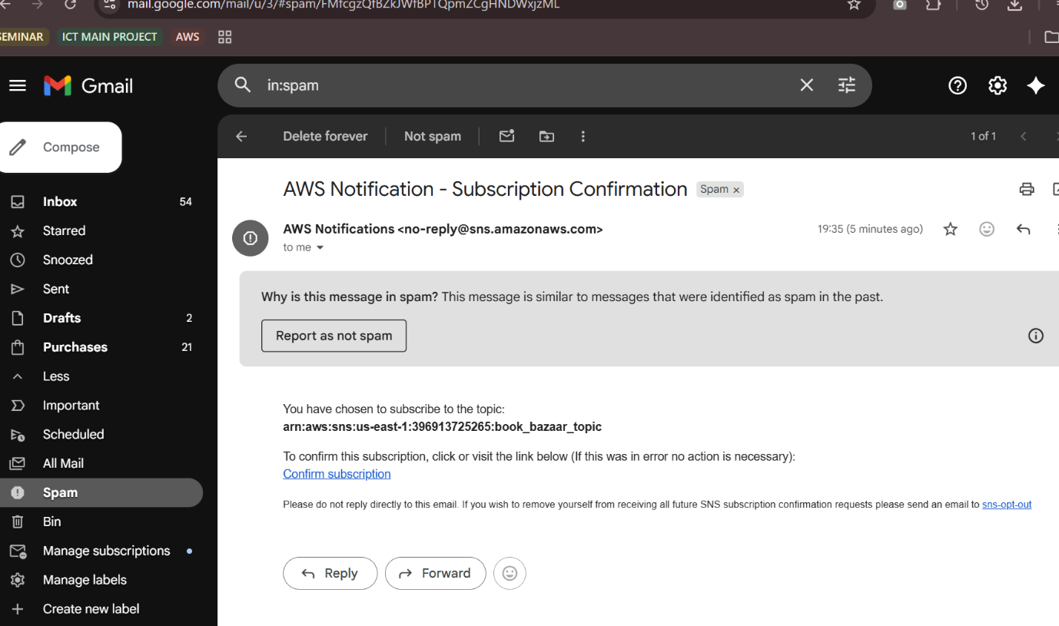Navigate to the subscribed Email account and Click on the confirm subscription in the AWS Notification- Subscription Confirmation mail.

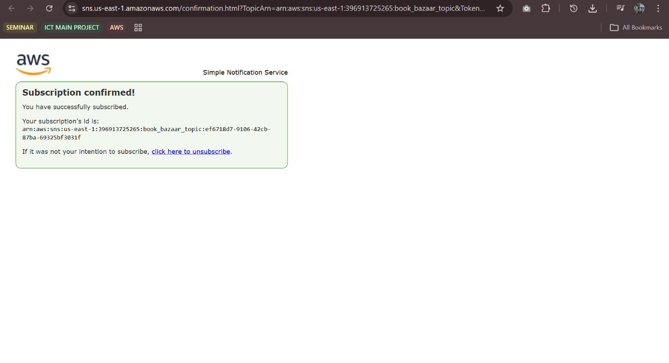

* + Successfully done with the SNS mail subscription and setup, now store the ARN link.

**Milestone 4: Backend Development and Application Setup**

* **Activity 4.1: Develop the backend using Flask**
  + 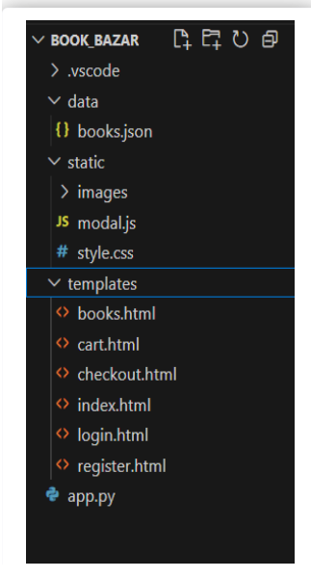File Explorer structure

**Description of the code:**

* **Flask App Initialization**

**Imports and Configuration:**

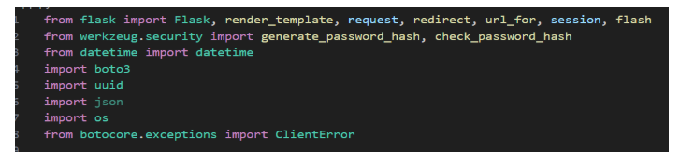

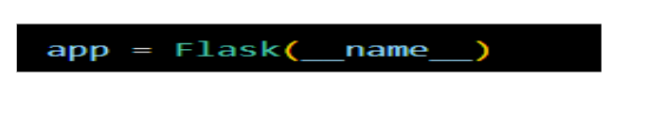**Description**: This project uses Flask for routing, session management, and user authentication with secure password hashing. It integrates AWS services via Boto3 for handling data storage, notifications, and unique user operations.

**Description:** A new Flask application instance is initialized, and a secret key is set to securely manage user sessions and protect against cookie tampering.

* 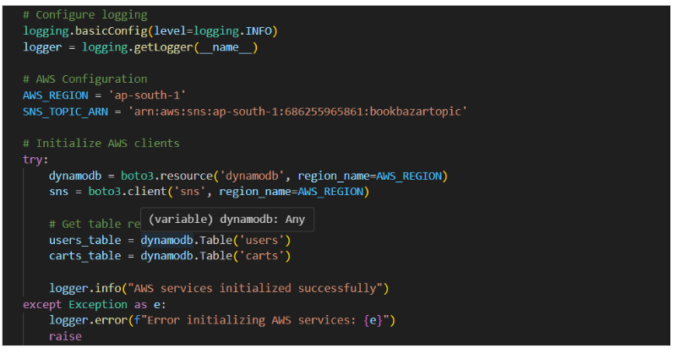**Dynamodb and SNS Setup:**

**Description**: Use **boto3** to connect to **DynamoDB** for handling user registration, movie bookings database operations and also mention region_name where Dynamodb tables are created.

* **SNS Connection**
  + **Description:** Configure **SNS** to send notifications when a book order is placed. Paste your stored ARN link in the sns_topic_arn space, along with the region_name where the SNS topic is created. Also, specify the chosen email service in SMTP_SERVER (e.g., Gmail, Yahoo, etc.) and enter the subscribed email in the SENDER_EMAIL section. Create an ‘App password’ for the email ID and store it in the SENDER_PASSWORD section.
* **Function to send the Notifications:**

**Description:** This function sends a booking confirmation email using AWS SNS. It formats the booking details into a message and publishes it to a specified SNS topic, notifying the user via email about their cart and booking.

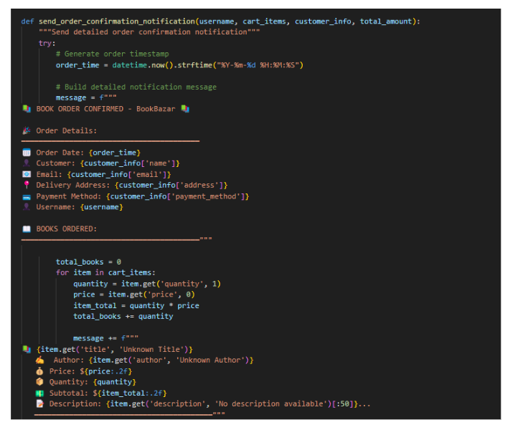

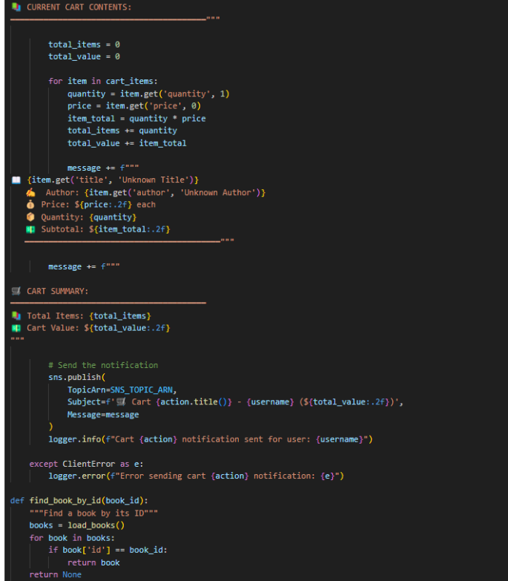

* **Routes for Web Pages**
* **Register User:** Collecting registration data, hashes the password, and stores user details in the database.

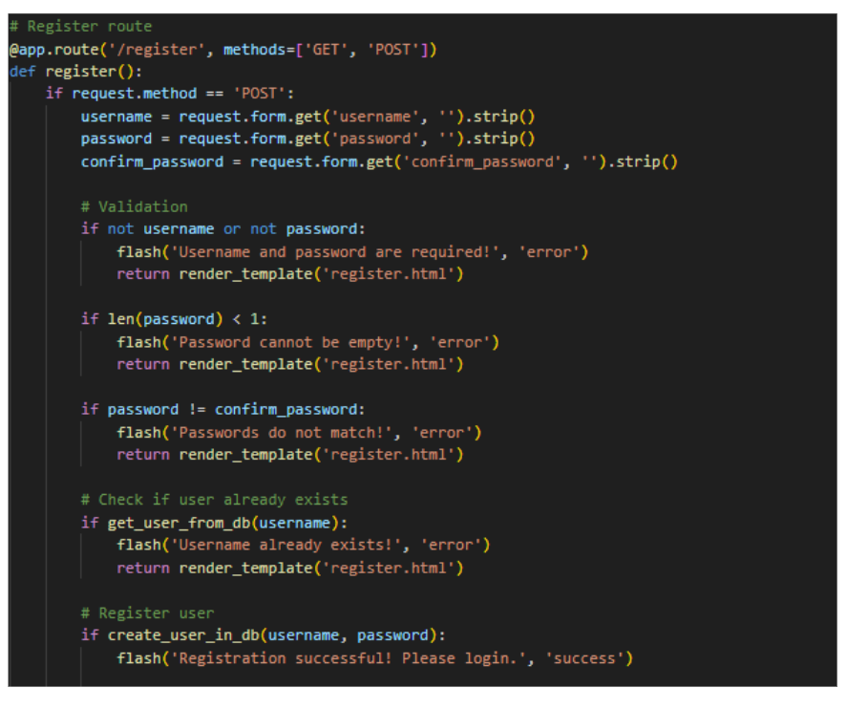

* 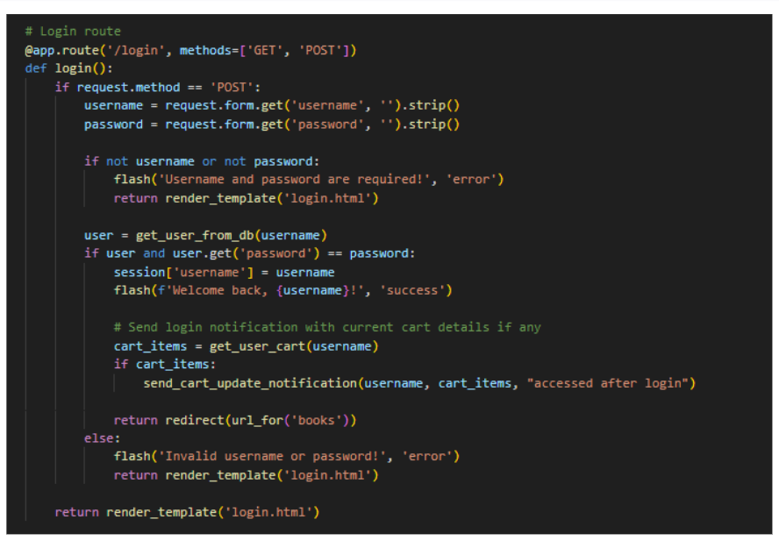**login Route (GET/POST)**: Verifies user credentials, increments login count, and redirects to the dashboard on success.
* These Flask routes handle key navigation in the app: /logout logs out the user by clearing the session and showing a flash message; /home is a protected route accessible only to logged-in users; /about and /contact_us render static pages with information about the app and ways to get in touch.

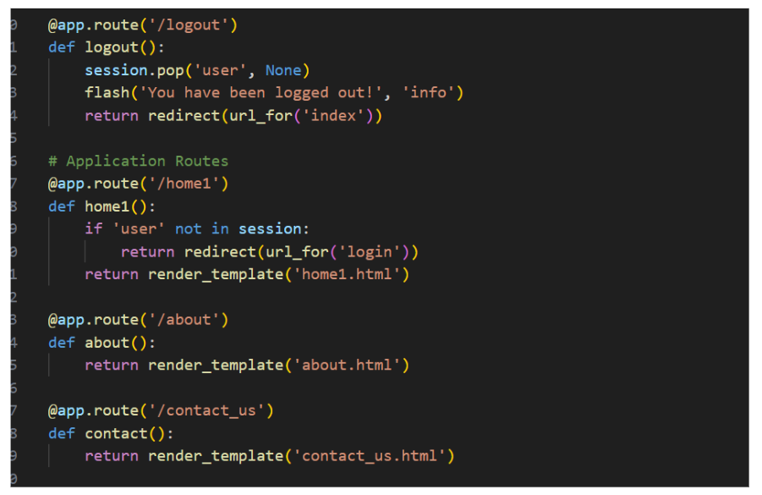

* **Booking Page Route:**

**Description:** This route displays the booking page (books.html) with movie, theater, address, and price details passed as query parameters. It ensures only logged-in users can access the page.

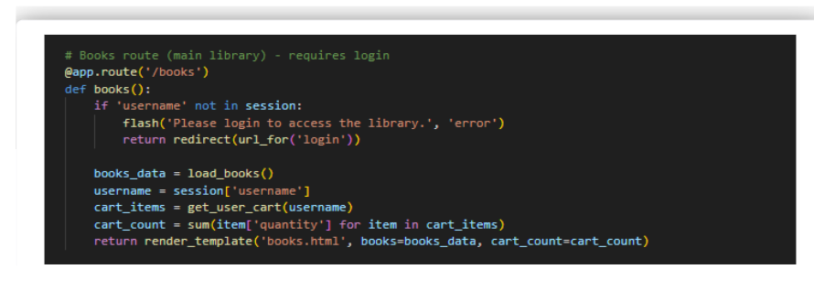

* **Cart Page Route:**

**Description:** Secure the user dashboard and implement a route to add items to the cart, storing them in DynamoDB with item details and a timestamp.

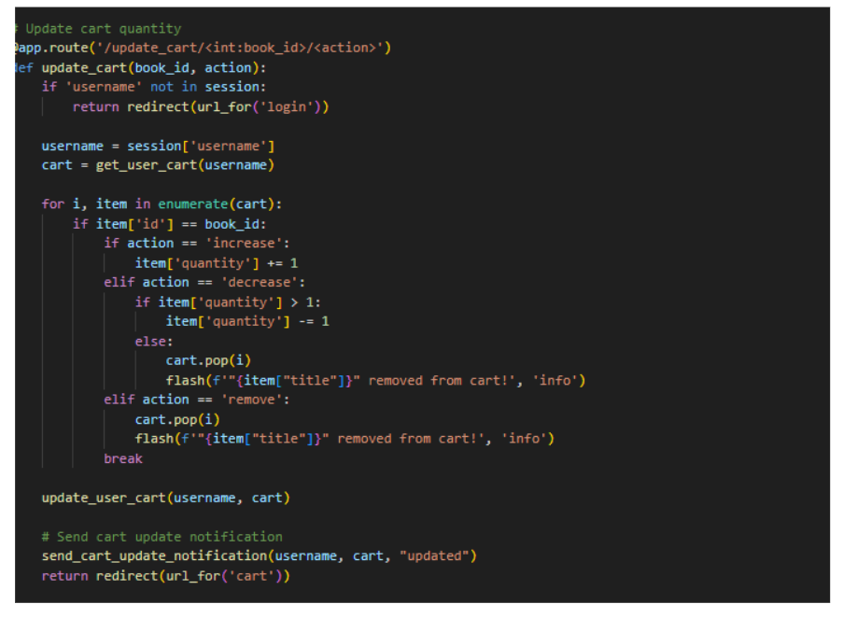

**Application Entry point:**

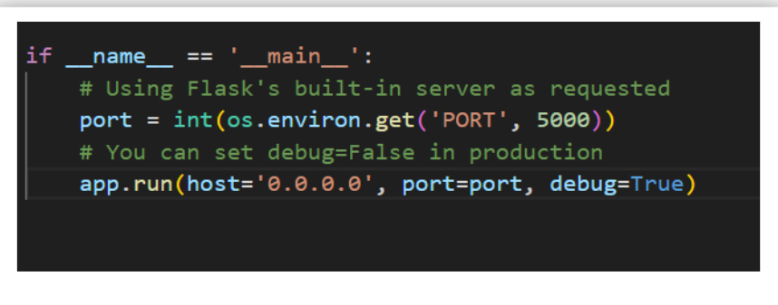

**Description**: This block starts the Flask application using the built-in development server, setting the host, port, and enabling debug mode for easier development and testing.

**Milestone 5: IAM Role Setup**

* **Activity 5.1: Create IAM Role.** 
  + 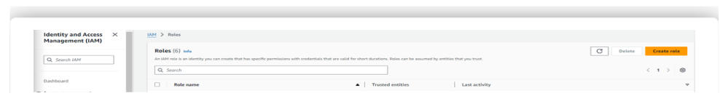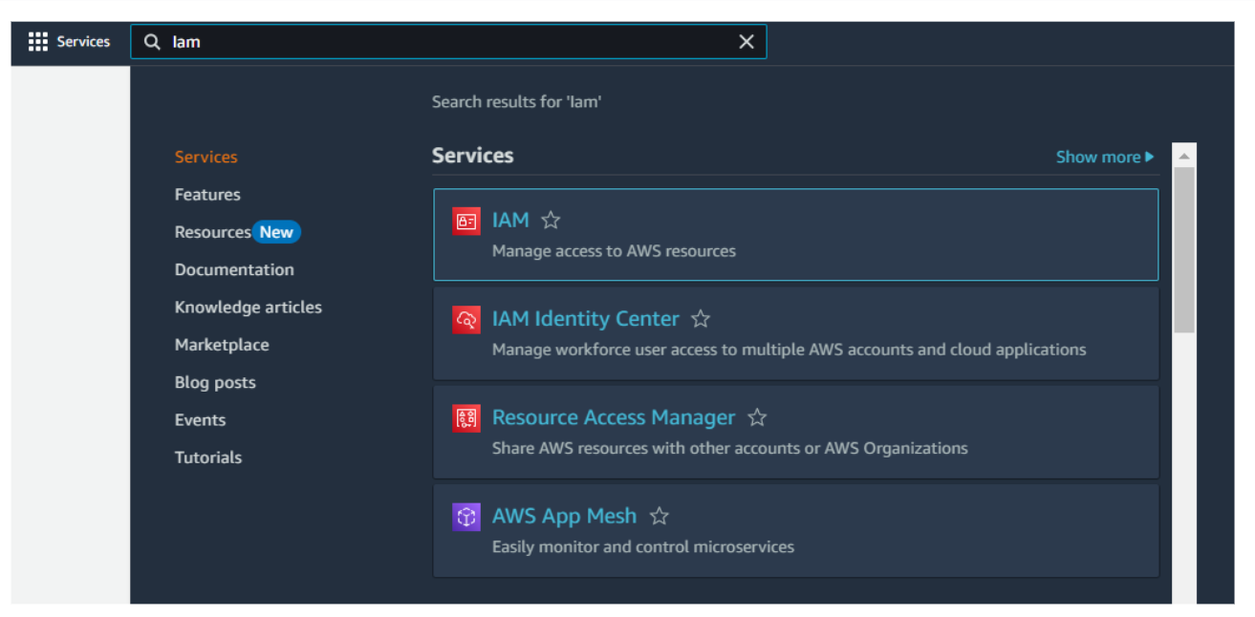In the AWS Console, go to IAM and create a new IAM Role for EC2 to interact with DynamoDB and SNS.

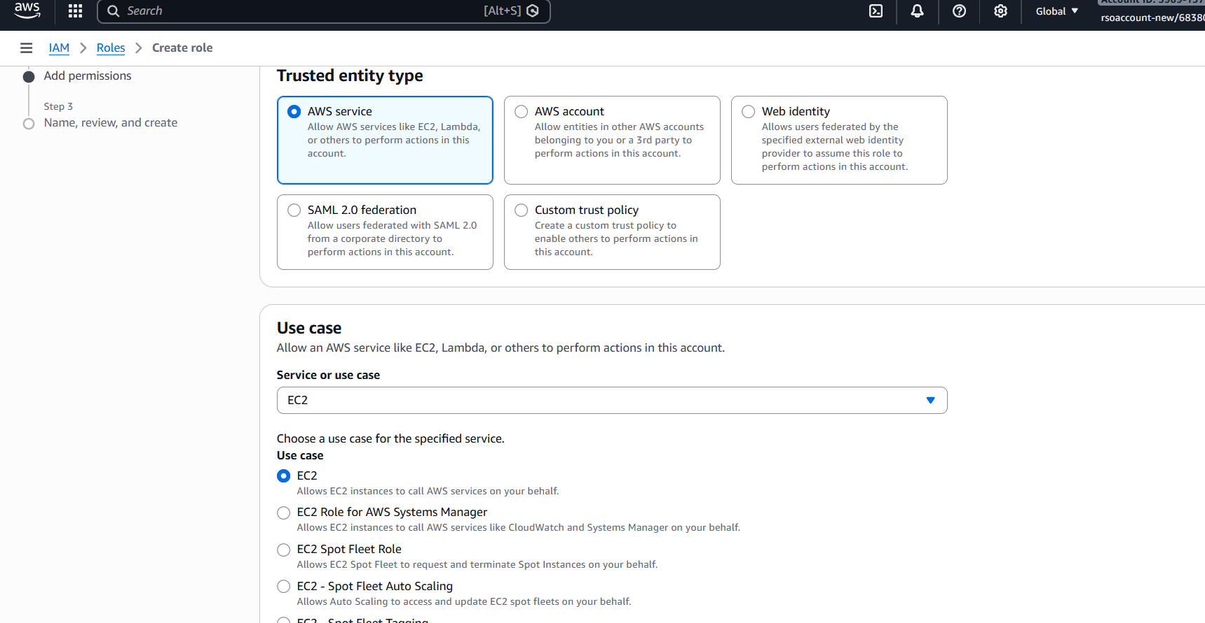

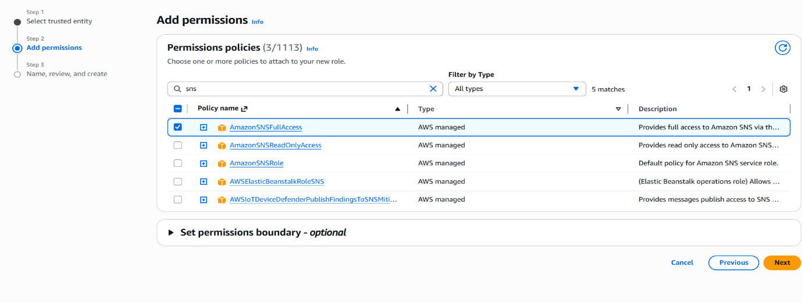

* **Activity 5.2: Attach Policies.**

Attach the following policies to the role:

* AmazonDynamoDBFullAccess: Allows EC2 to perform read/write operations on DynamoDB.
* AmazonSNSFullAccess: Grants EC2 the ability to send notifications via SNS.

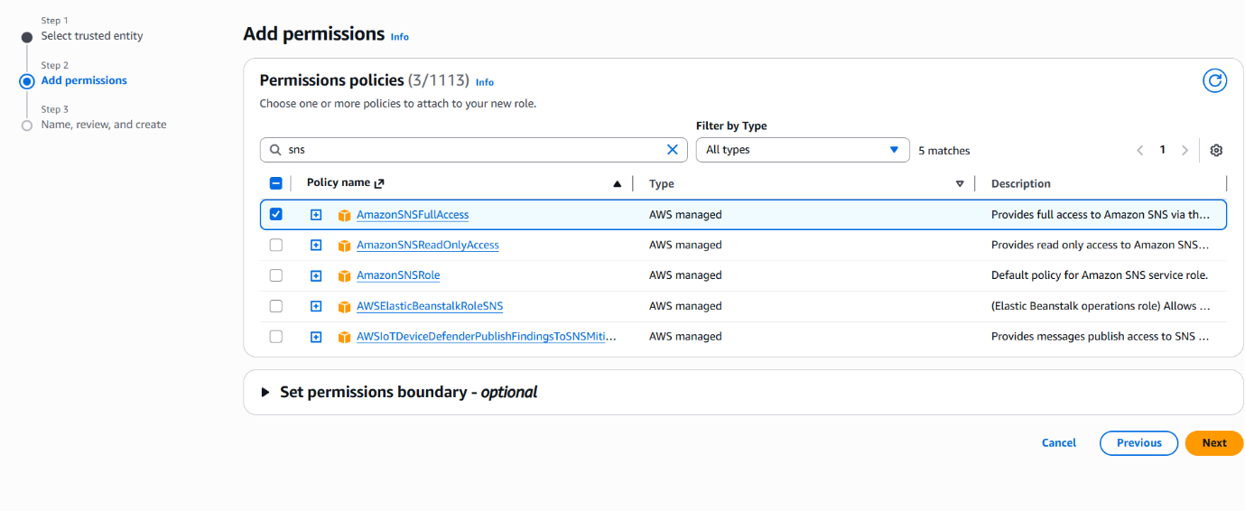

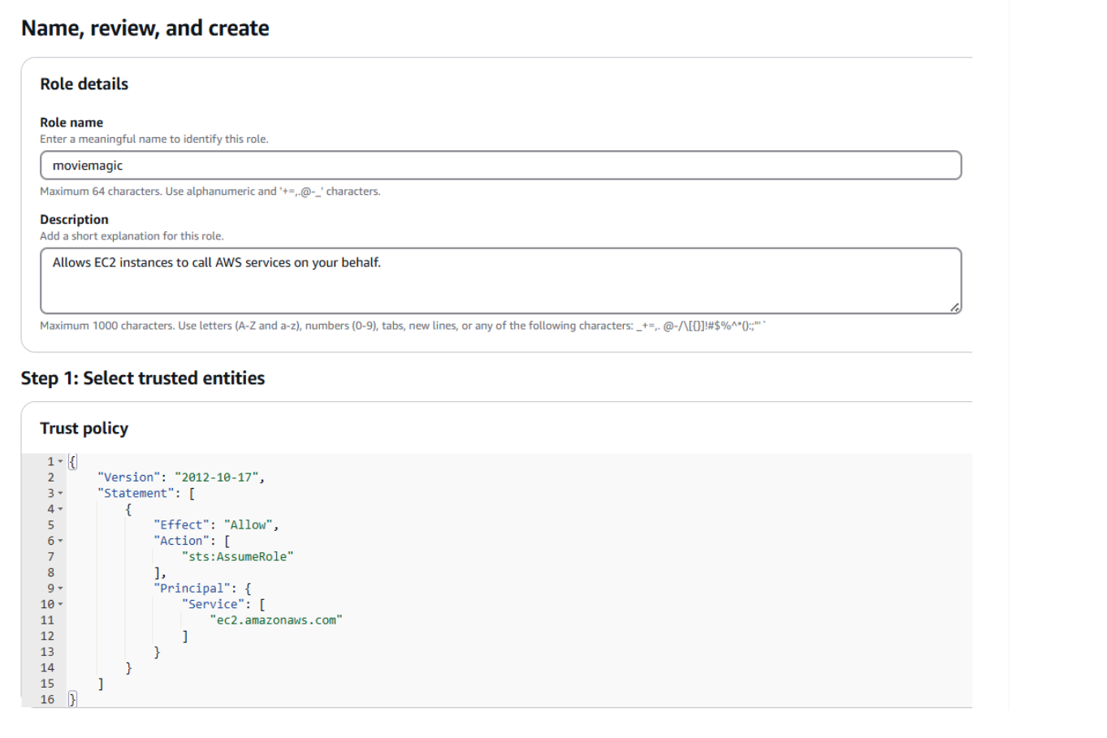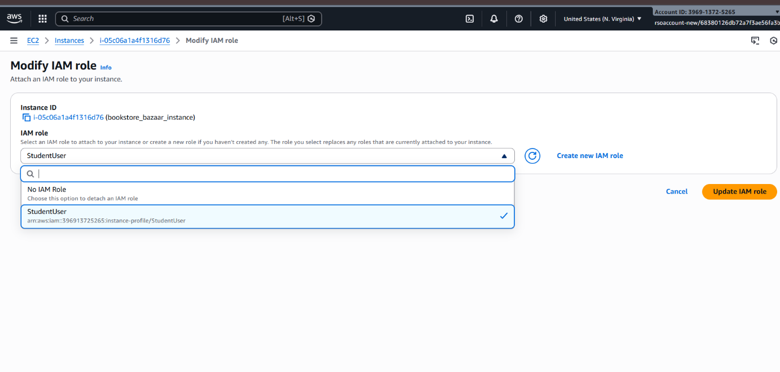

StudentUser

**StudentUser**

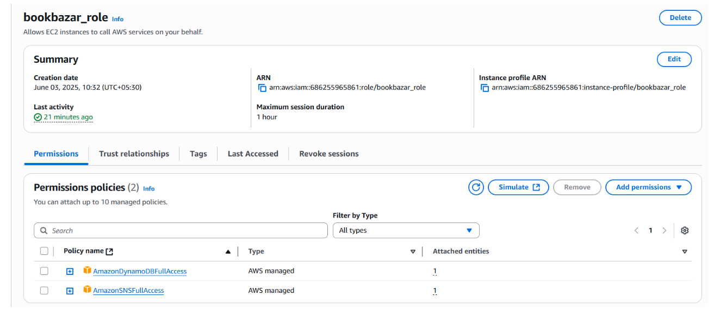

**Milestone 6: EC2 Instance Setup**

* **Note: Load your Flask app and Html files into GitHub repository.**

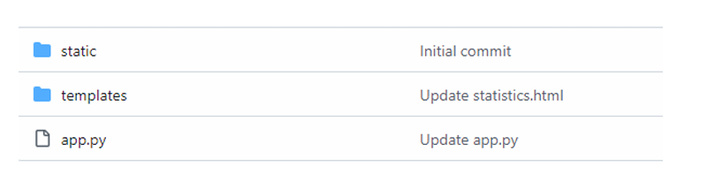

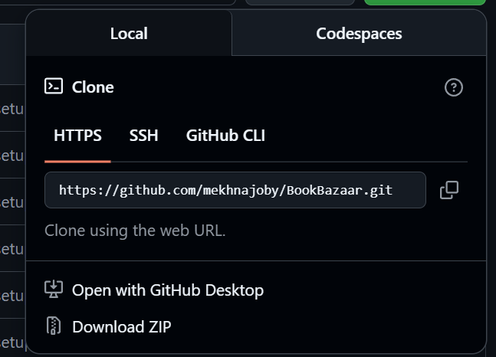

* **Activity 6.1: Launch an EC2 instance to host the Flask application.**
* **Launch EC2 Instance** 
  + In the AWS Console, navigate to EC2 and launch a new instance.

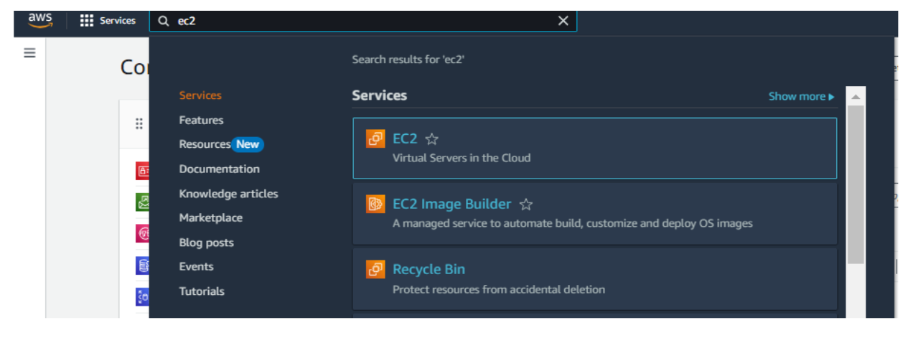

* Click on Launch instance to launch EC2 instance

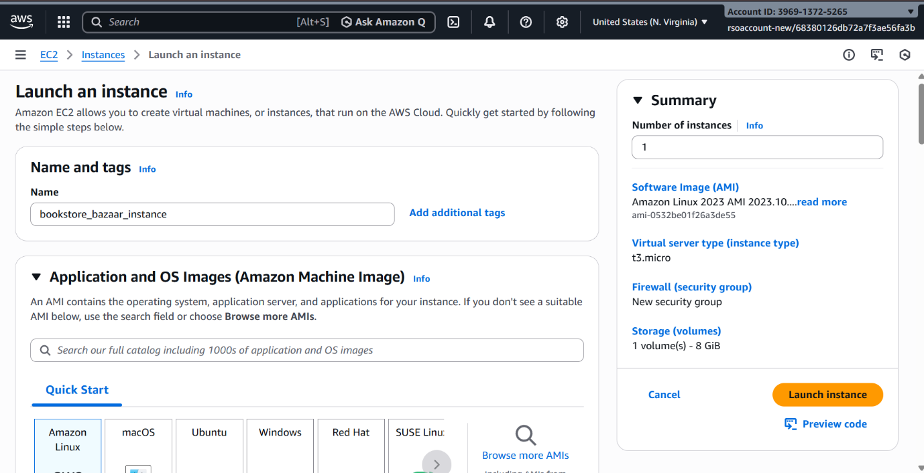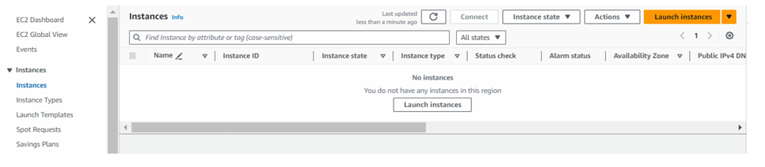

* Choose Amazon Linux 2 or Ubuntu as the AMI and t2.micro as the instance type (free-tier eligible).

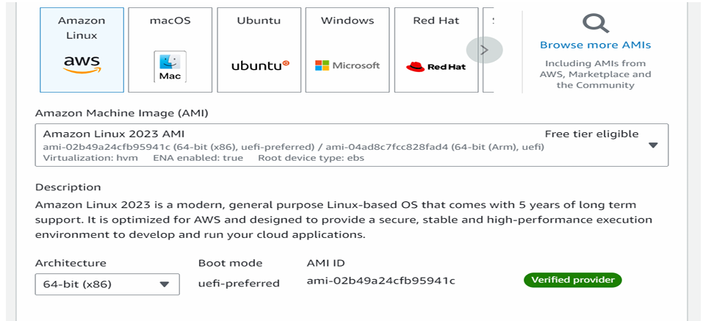

* 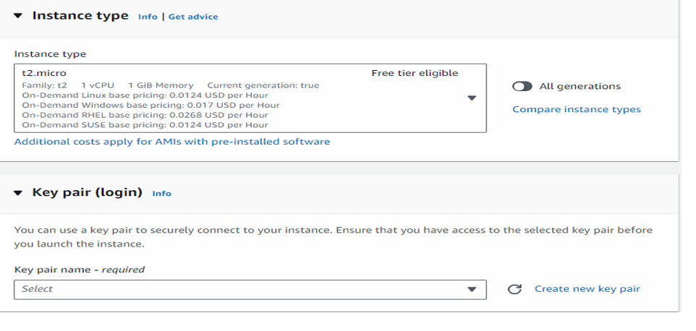Create and download the key pair for Server access.

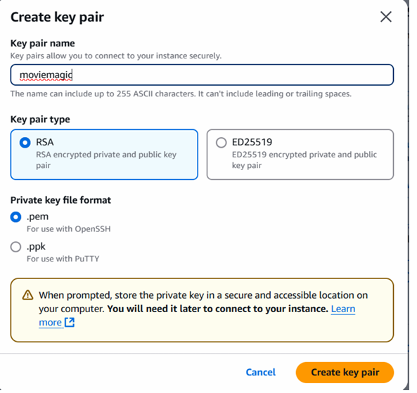

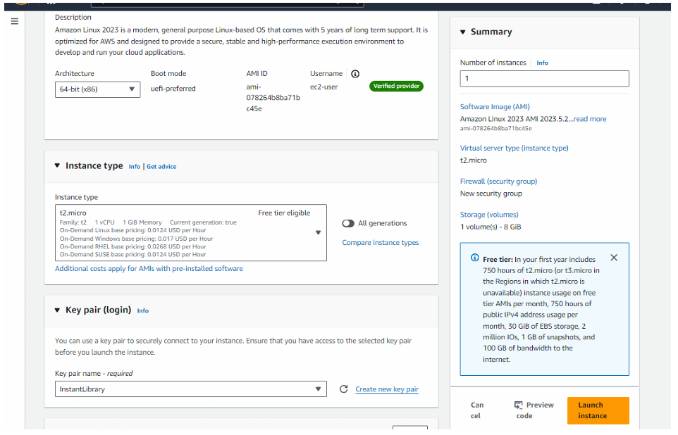

* **Activity 6.2: Configure security groups for HTTP, and SSH access.**

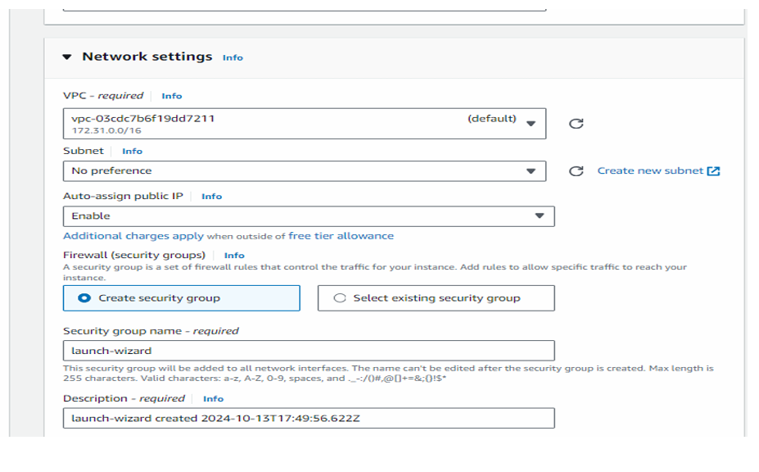

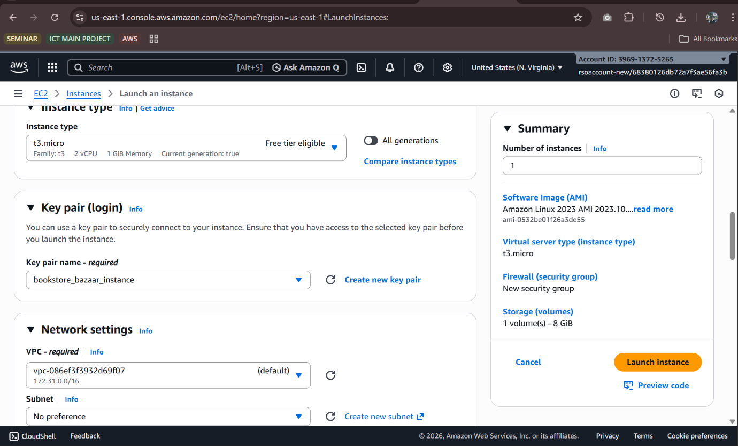

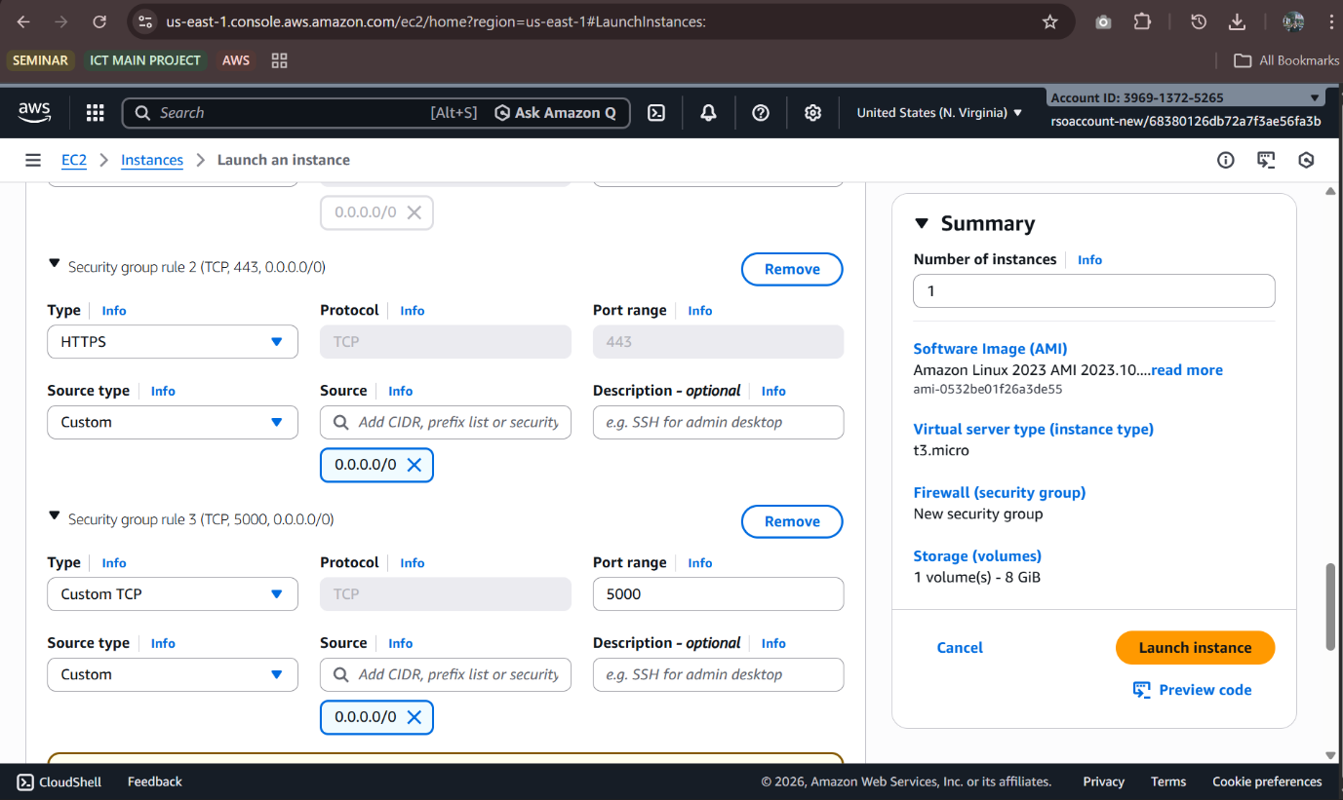

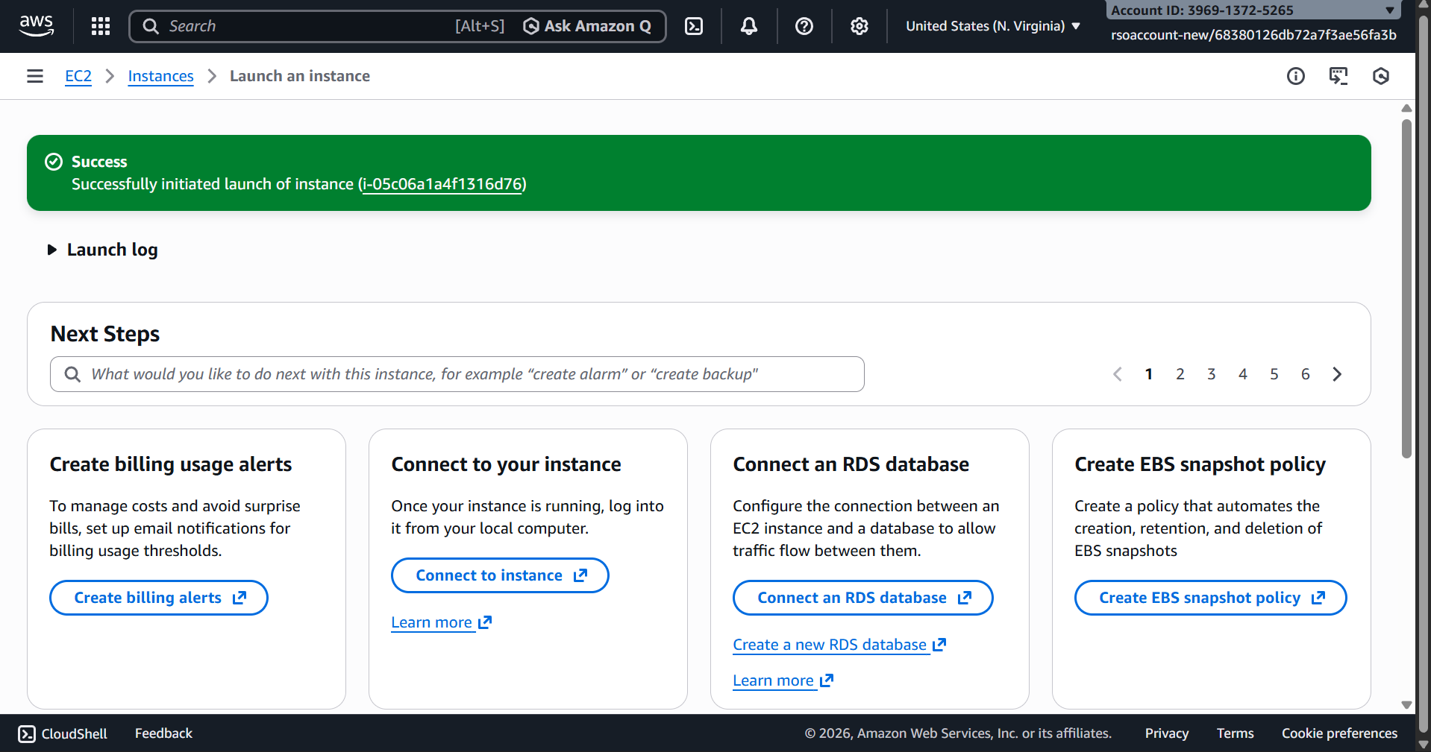

* To connect to EC2 using EC2 Instance Connect, start by ensuring that an IAM role is attached to your EC2 instance. You can do this by selecting your instance, clicking on Actions, then navigating to Security and selecting Modify IAM Role to attach the appropriate role. After the IAM role is connected, navigate to the EC2 section in the AWS Management Console. Select the EC2 instance you wish to connect to. At the top of the EC2 Dashboard, click the Connect button. From the connection methods presented, choose EC2 Instance Connect. Finally, click Connect again, and a new browser-based terminal will open, allowing you to access your EC2 instance directly from your browser.

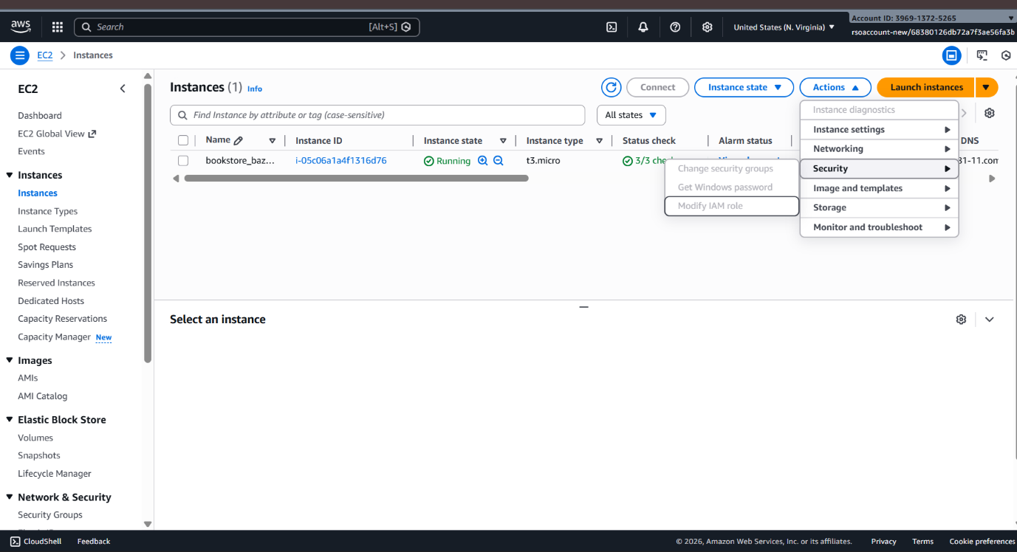

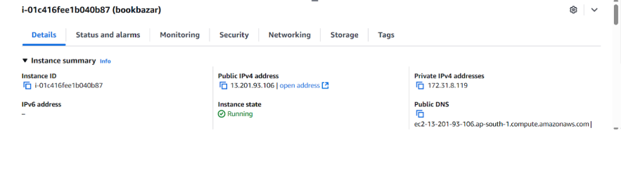



* Now connect the EC2 with the files

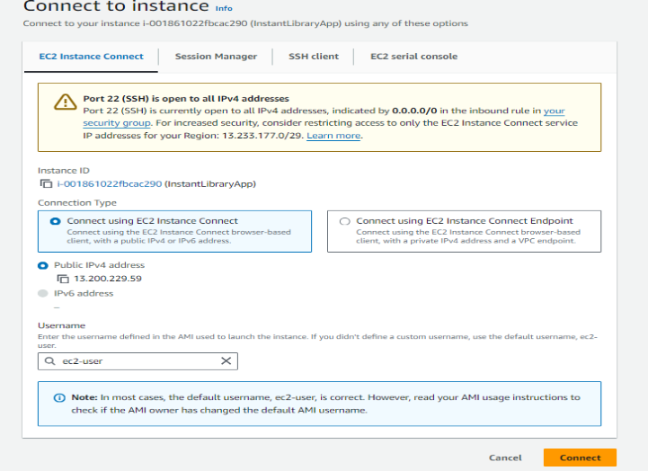

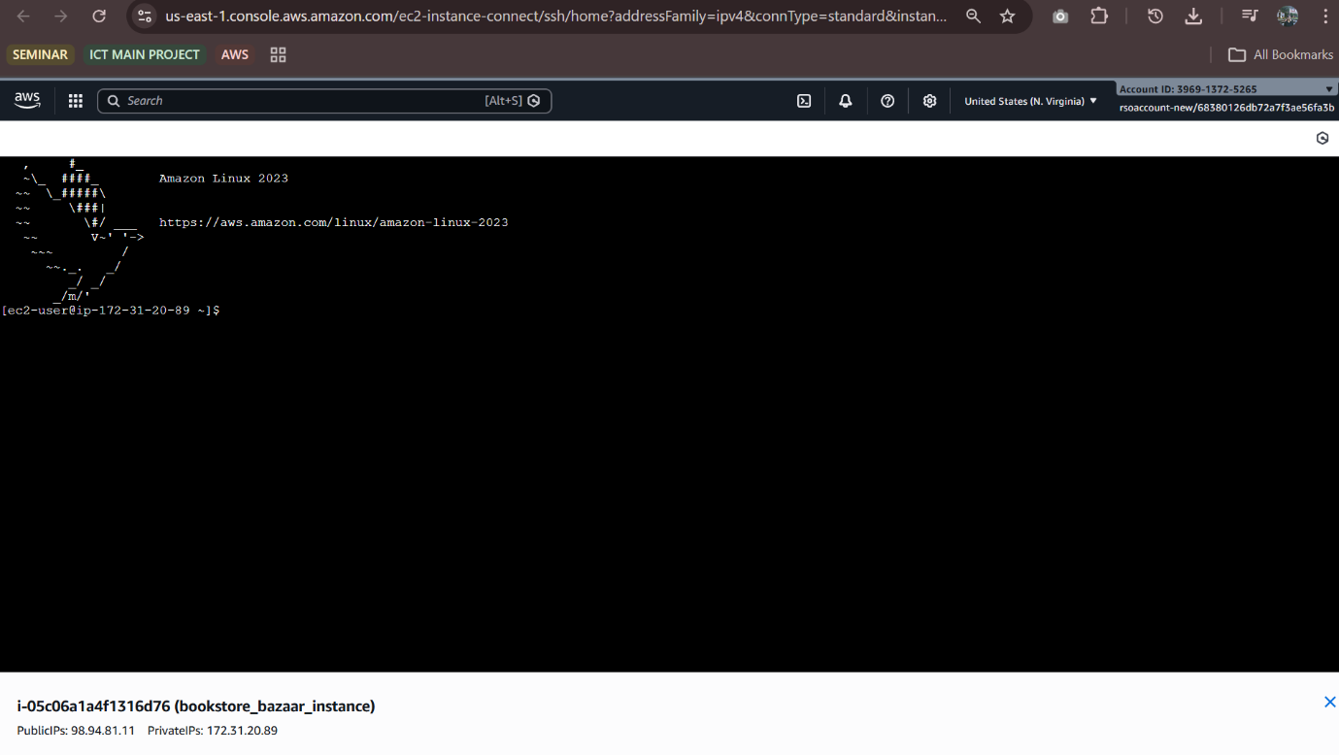

**Milestone 7: Deployment on EC2**

* **Activity 7.1: Install Software on the EC2 Instance**

Install Python3, Flask, and Git:

On Amazon Linux 2:

sudo yum update -y

sudo yum install python3 git

sudo pip3 install flask boto3

Verify Installations:

flask --version

git –version

* **Activity 7.2: Clone Your Flask Project from GitHub**

Clone your project repository from GitHub into the EC2 instance using Git.

Run: ‘https://github.com/mekhnajoby/ BookBazaar.git

Note: change your-github-username and your-repository-name with your credentials here: ‘https://github.com/mekhnajoby/ BookBazaar.git’

* This will download your project to the EC2 instance.

**To navigate to the project directory, run the following command:**

cd BookBazaar  
           

**Once inside the project directory, configure and run the Flask application by executing the following command with elevated privileges:**

**Run the Flask Application**

sudo flask run --host=0.0.0.0 --port=5000

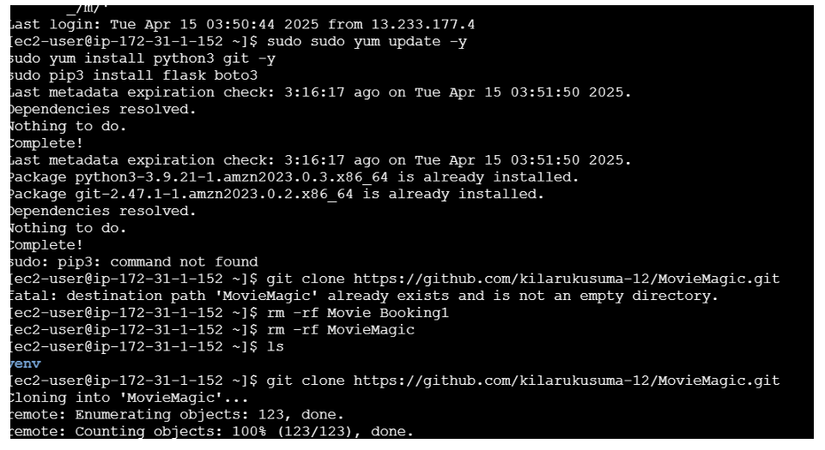

**Verify the Flask app is running:**

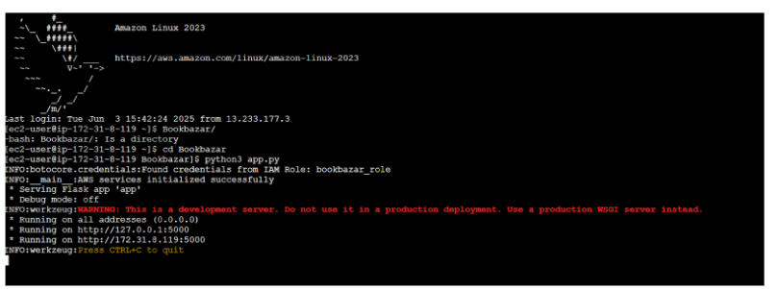http://your-ec2-public-ip ○ Run the Flask app on the EC2 instance

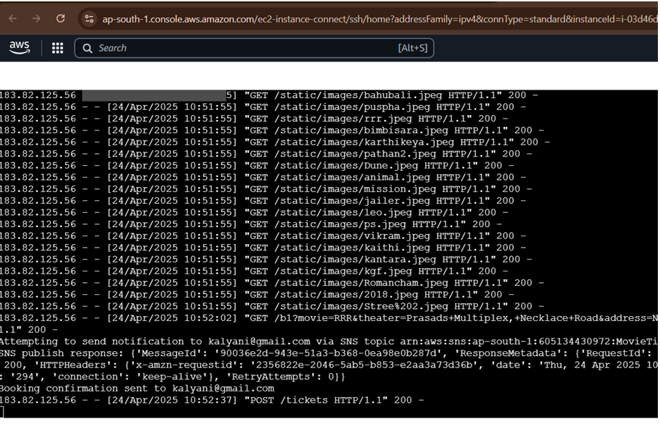

**Access the website through:  
                                            PublicIPs:** **https://13.203.199.178.5000**

**Milestone 8: Testing and Deployment**

**Activity 8.1: Conduct functional testing to verify user registration, login, books collection, and notifications.**

**Index Page:**

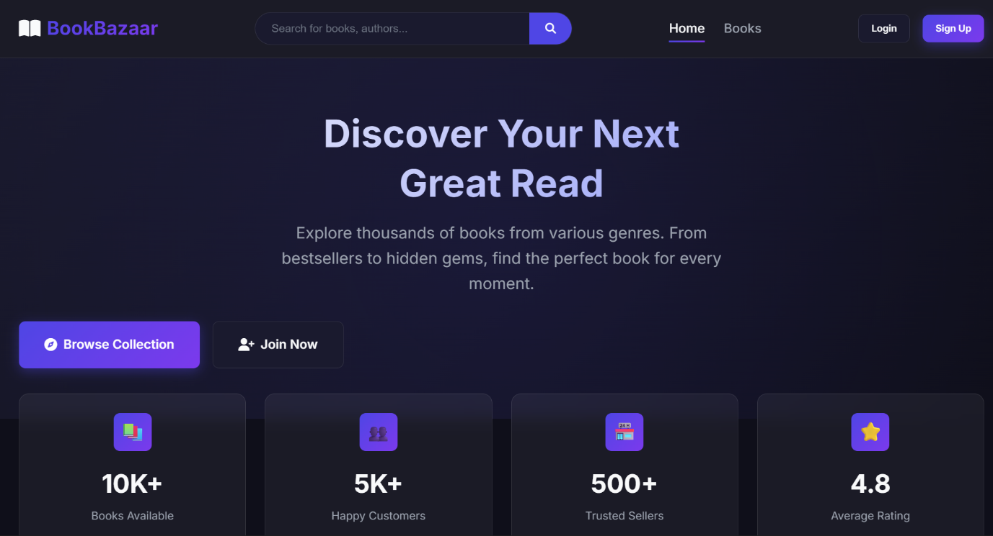

**Register** **Page:**

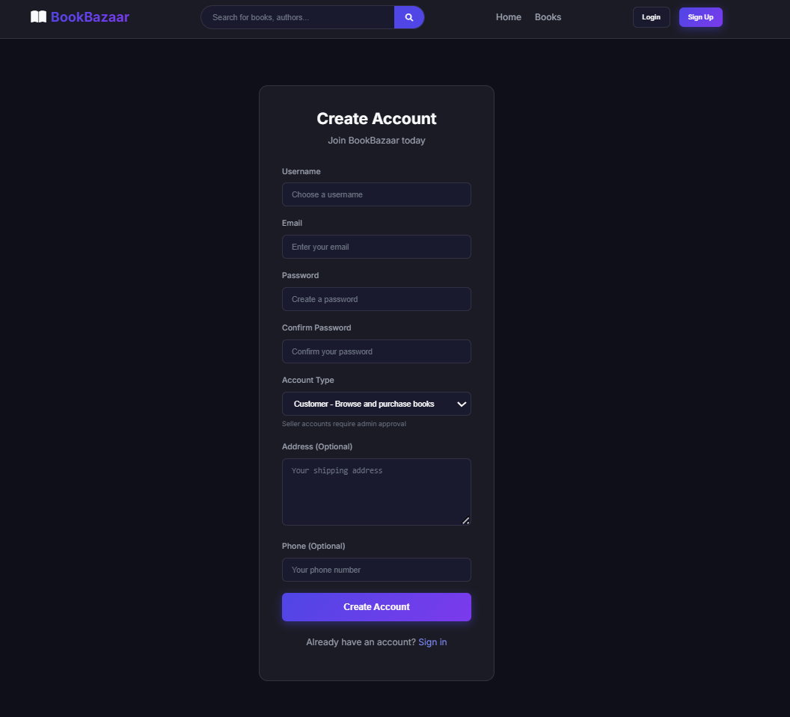

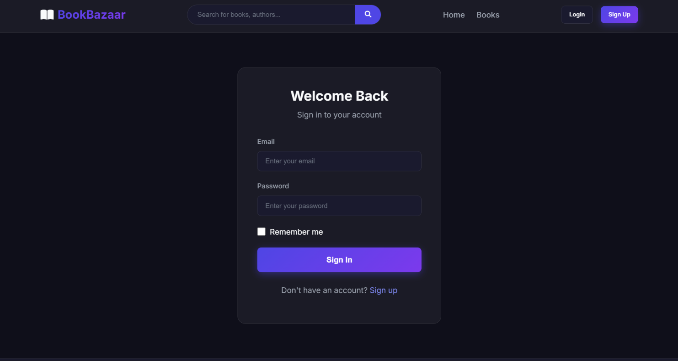**Login Page:**

**Books Page:**

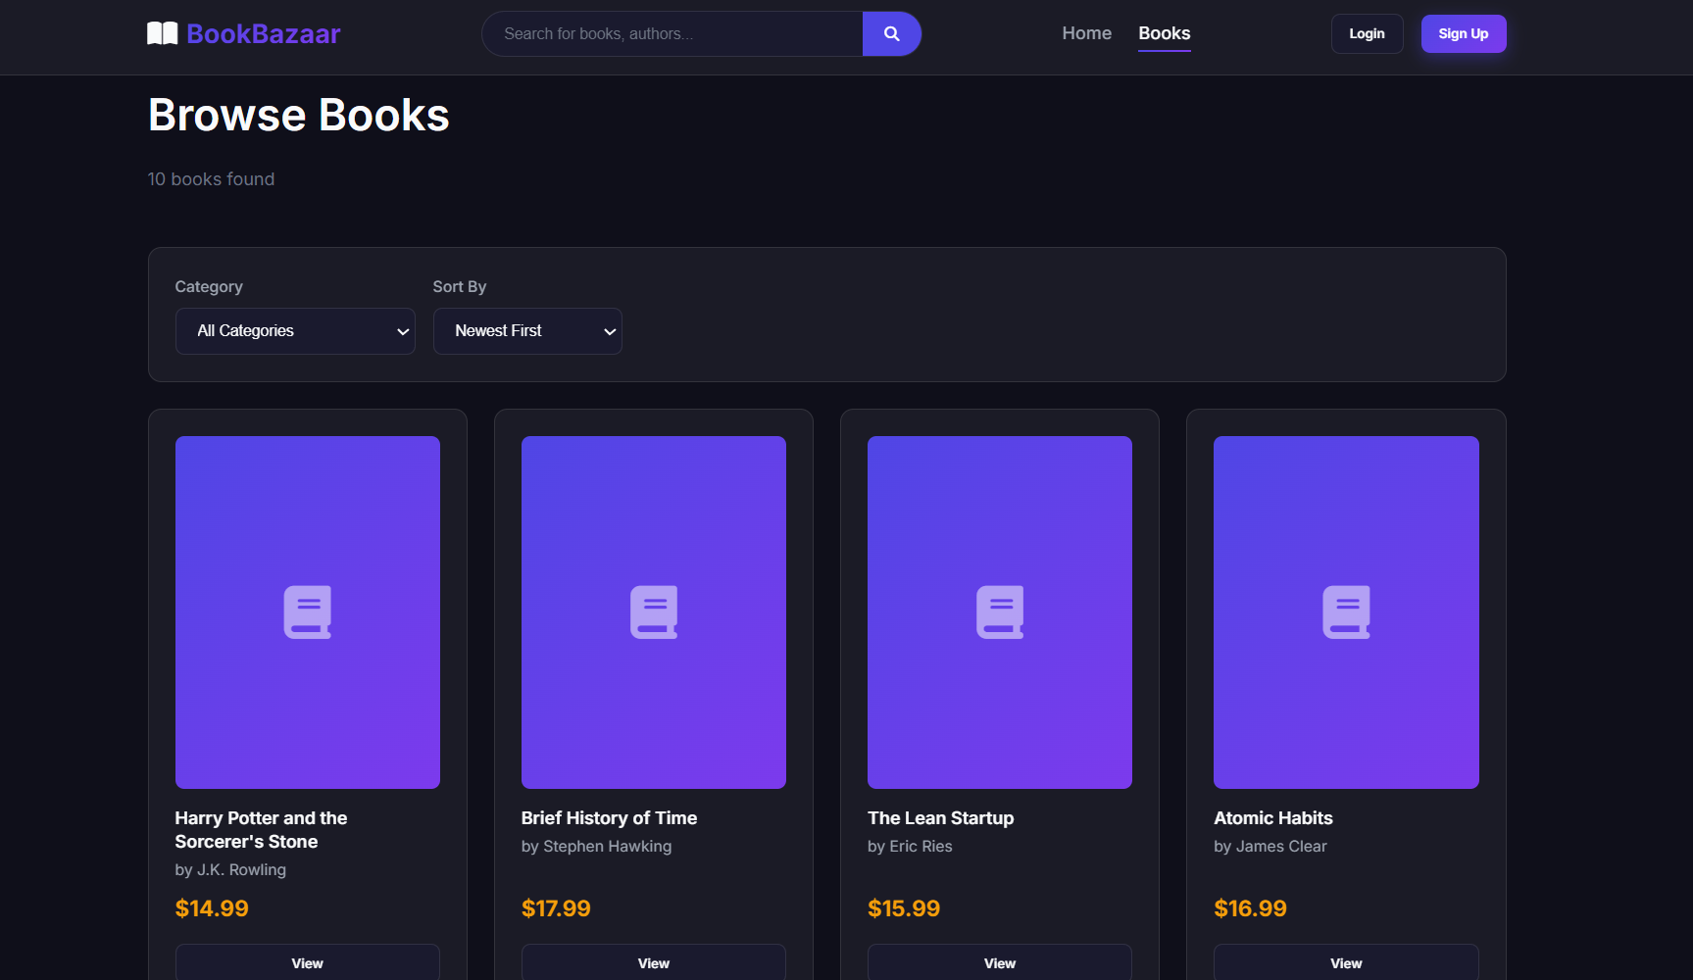

**Cart Page:**

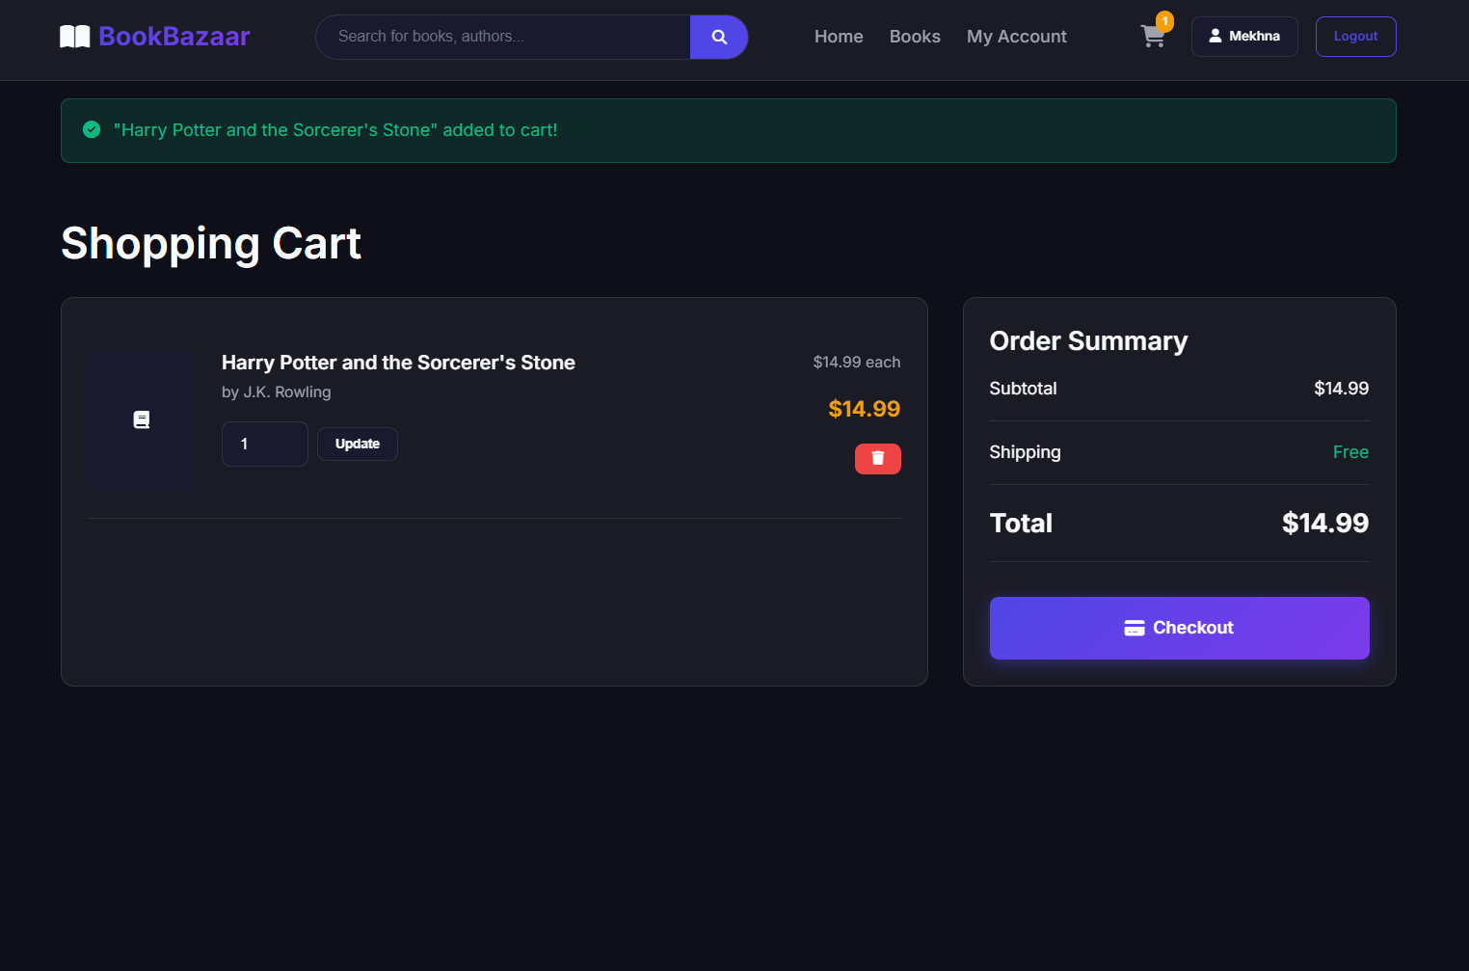

**Confirmation Page:**

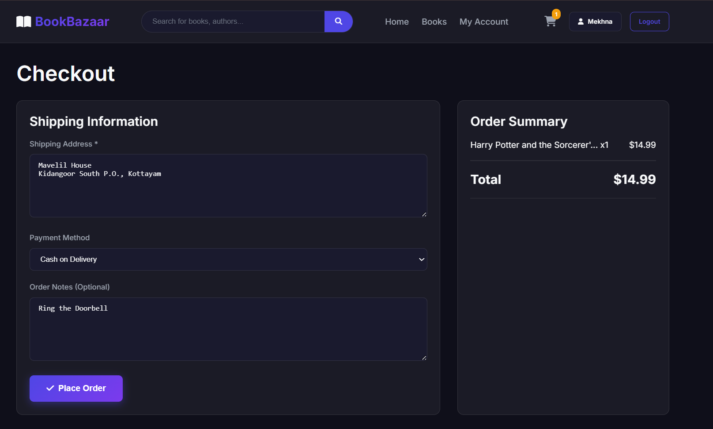

**Dynamodb Database updations:**

**1. BookBazaar users table**

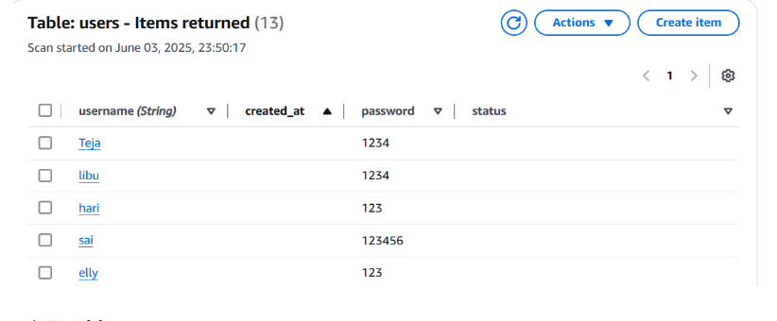

**2. BookBazaar cart table**

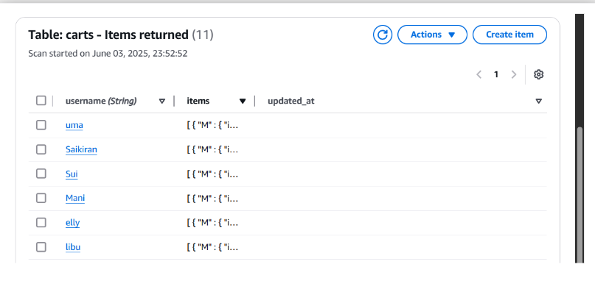

**3. Mail to the user**

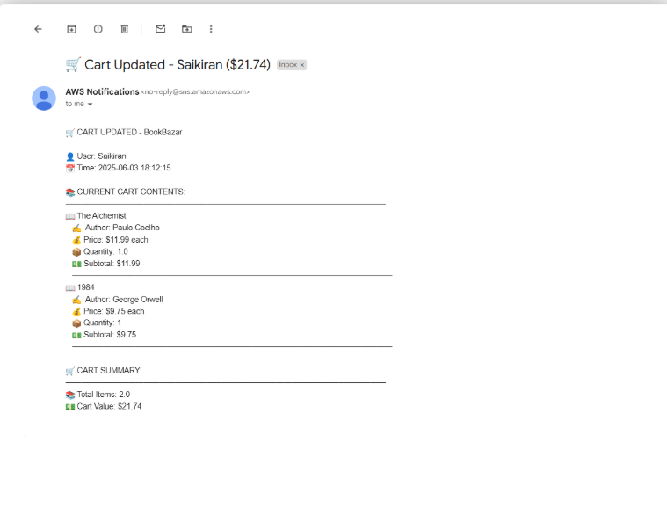

**Conclusion:**

The BookBazaar online bookstore platform has been successfully developed and implemented, leveraging a robust, cloud-native architecture. By utilizing core AWS services such as EC2 for secure and scalable hosting, DynamoDB for efficient management of book catalogues, order data, and user information with low latency, and SNS for sending real-time notifications, the platform delivers a scalable and user-friendly experience for Browse, purchasing, and managing books.

This solution effectively addresses the increasing demand for online reading and book commerce by providing a seamless platform for customers to browse and purchase books, manage orders, and receive instant updates. It also empowers sellers to upload and manage book listings, track sales, and manage inventory, while administrators can oversee transactions, validate seller credentials, and monitor platform operations.

The cloud-based infrastructure ensures that BookBazaar can handle a high volume of users and transactions, maintaining speed and reliability. The integration of FastAPI with AWS services enables smooth backend operations, including user authentication, book Browse, shopping cart management, and secure order processing.

Comprehensive development and integration have confirmed that all core functionalities—from user registration and login to order confirmation via real-time notifications—operate seamlessly. The platform's modern approach and responsive design further enhance the user experience, making book buying and selling efficient and enjoyable.

In conclusion, BookBazaar stands as a powerful demonstration of how cloud technologies can modernize traditional services. It provides an efficient, scalable, and intuitive solution for online book commerce, showcasing the potential of full-stack cloud applications in transforming the traditional bookstore into a dynamic online ecosystem tailored for the digital era.